Concepts towards a sustainable synthesis design

Marco Eissen, Swiss Federal Institute of Technology, Zurich, Switzerland; Jürgen O. Metzger, Carl von Ossietzky Universität, Oldenburg, Germany; Konrad Hungerbühler, Swiss Federal Institute of Technology, Zurich, Switzerland

Agenda 21 calls for “criteria and methodologies for the assessment of environmental impacts and resource requirements throughout the full life cycle of products and processes” (Chapter 4.20). Synthesis design represents the very beginning of the life cycle of chemical substances and, consequently, has a correspondingly strong influence on final resource utilization and environmental impact. Therefore, with regard to related assessment tools, emphasis on the early stages of development is especially important. Which alternatives in Figure 1(a-c) are the ‘greenest’ and the most economical?
a) + b) c)
Figure 1 Search for the most eco-efficient alternative.
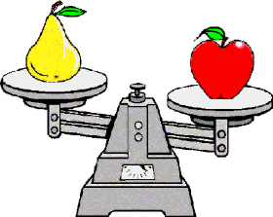
With EATOS (Environmental Assessment Tool for Organic Syntheses) a concept for research and training has been developed and incorporated into a software program that now provides the opportunity to carry out, in the laboratory, a simple and rapid comparison and weak-point analysis of syntheses and syntheses sequences with respect to resource utilization and environmental compatibility. An industrial case study will be used to demonstrate the benefits and limitations of an early assessment.
Literature: M. Eissen, J. O. Metzger, Environmental Performance Metrics for Daily Use in Synthetic Chemistry, Chem. Eur. J. 2002, 8, 3580-3585.

