API-Mass Spectrometric Investigations of the Mechanism of Organocatalytic Reactions

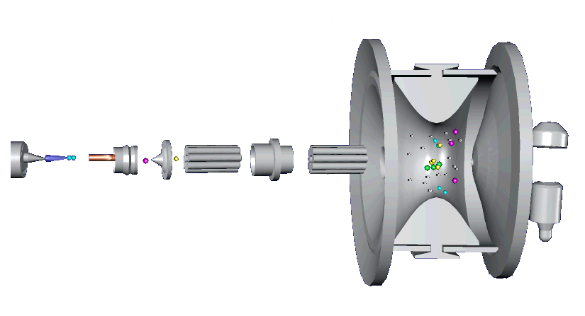

Jürgen O. Metzger

Institut für Reine und Angewandte Chemie

Universität Oldenburg, Postfach 2503, 26111 Oldenburg

e-mail: juergen.metzger@uni-oldenburg.de

API-MS on-line coupled to a micro reactor has been shown to be a new and important tool to investigate chemical reactions in solution and to detect and to characterize mass spectrometrically the intermediates and, most importantly, the transient intermediates in the reacting solution. This project aims towards the development of methods for the API-MS investigation of organocatalytic reactions in solution using the enantioselective Hajos-Eder-Sauer-Wiechert reaction as example. The intermediates in the catalytic cycle will be detected and characterized by ESI-MS/MS. Further important organocatalytic reactions will be studied, partially in cooperation with other research groups participating in the SSP.

Introduction
We introduced a novel method to investigate directly transient C-radicals in preparatively important radical chain reactions in solution ^{[1]} as well as radical cations in radical cation chain reactions ^{[2]} by ESI-MS coupled to a micro reactor system.
2. State of the art, preliminary work
Some electron transfer initiated Diels-Alder reactions were studied e. g. the reaction of phenylvinylsulfide (1) and cyclopentadiene (2) to give 5-phenylthionorbornene (3) mediated by tris(p-bromophenyl)aminium hexachloroantimonate (TPBA^{•+}SbCl₆⁻) (Scheme 1).^{[3]} Using the MS/MS technique, which allows the separation of the ions of interest from all other ions, and by CID their mass spectrometric characterization, we could detect and identify both radical cations 4 (Figure 1a) and 5 (Figure 1b) unambiguously in the reacting solution.
Scheme 1. The TPBA^{•+}SbCl₆⁻ initiated radical cation chain reaction of phenylvinylsulfide (1) and cyclopentadiene (2) to give the Diels-Alder product 5-(phenylthio)norbornene (3) via the reactive intermediates 4 and 5.
Figure 1. Positive ESI mass spectrum of the reacting solution of phenylvinylsulfide (1), cyclopentadiene (2) and TPBA^{•+}SbCl₆⁻ in dichloromethane after a reaction time of approximately 14 seconds.
a) ESI-MS/MS spectrum of ion m/z 136 of the reacting solution showing identical fragmentations compared to the APCI-MS/MS spectrum of the authentic radical cation 4 .
b) ESI-MS/MS spectrum of ion m/z 202 of the same reacting solution showing identical fragmentations compared to the authentic radical cation 5.

We studied two examples of Michael additions: The base catalyzed addition of diethyl malonate to 2-butenon and to acrylonitrile, respectively. In both examples we could detect without any problems all intermediates. Most importantly, we could detect and characterize by ESI-MS for the first time the transient Michael adduct anion using our micro reactor coupled directly to the ESI-MS.
Recently, Santos et al. probed the mechanism of the Baylis-Hillman reaction by ESI-MS/MS and could detect directly the important intermediates of the catalytic cycle.^{[4]}

3. Goals and work schedule
By direct coupling of a micro reactor with API-MS important organocatalytic reactions e. g. the Hajos-Eder-Sauer-Wiechert reaction (Scheme 2), amino acid catalyzed Mannich-type and Michael-type reactions, enantioselective α-chlorination of aldehydes and ketones with N-chlorosuccinimide will be studied and the intermediates in the catalytic cycle will be detected and characterized by ESI-MS/MS.
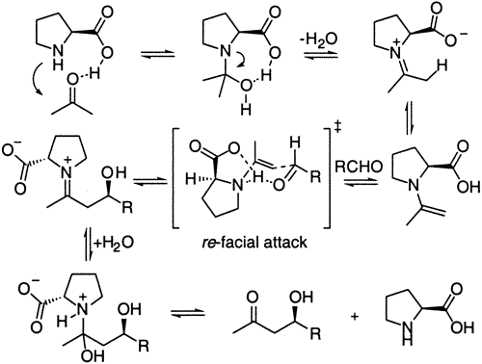

Scheme 2. . Enamine mechanism of the direct catalytic asymmetric aldol reaction catalyzed by L-Proline ⁵

In cooperation with Prof. Tietze, University of Göttingen, some reactions as the domino-Knoevenagel-hetero-Diels-Alder reaction, the domino-Knoevenagel-ene reactions and related transformations will be studied using our method. In these examples it will be most interesting and faszinating if it will be possible to detect and characterize by MS/MS-methods the different steps of the domino reaction. In cooperation with Prof. Bräse, University of Karlsruhe, a new asymmetric organocatalytic amination of carbonyl compounds by asymmetric cycloaddition will be investigated. Additionally, we are ready to study other interesting new reactions in the framework of this SSP1179.

[1] J. Griep-Raming, S. Meyer, T. Bruhn, J. O. Metzger, Angew. Chem. Int. Ed. 2002, 41, 15, 2738-2742.
[2] a) S. Meyer, J. O. Metzger, Anal. Bioanal. Chem. 2003, 377, 7-8, 1108-1114; b) S. Meyer, R. Koch, J. O. Metzger, Angew. Chem. Int. Ed. 2003, 42, 4700-4703.
[3] S. Fürmeier, J. O. Metzger, J. Am. Chem. Soc., 2004, 126, 14485-14492.
[4] L.S. Santos. C.H. Pavam, W.P. Almeida, F. Coelho, M.N. Eberlin, Angew. Chem. Int. Ed. 2004, 43, 4330-4333.
[5] K. Sakthivel, W. Notz, T. Bui, C. F. Barbas III, J. Am. Chem Soc. 2001, 123, 5260 – 5267.

